Bremer Bay School Camp 14-16 October 2020

The 12 students in Years 3-6 travelled to Twertup Field Studies Centre for a (3 days/2 nights) environmental education camp. The students were transported in staff and parent 4WD vehicles.
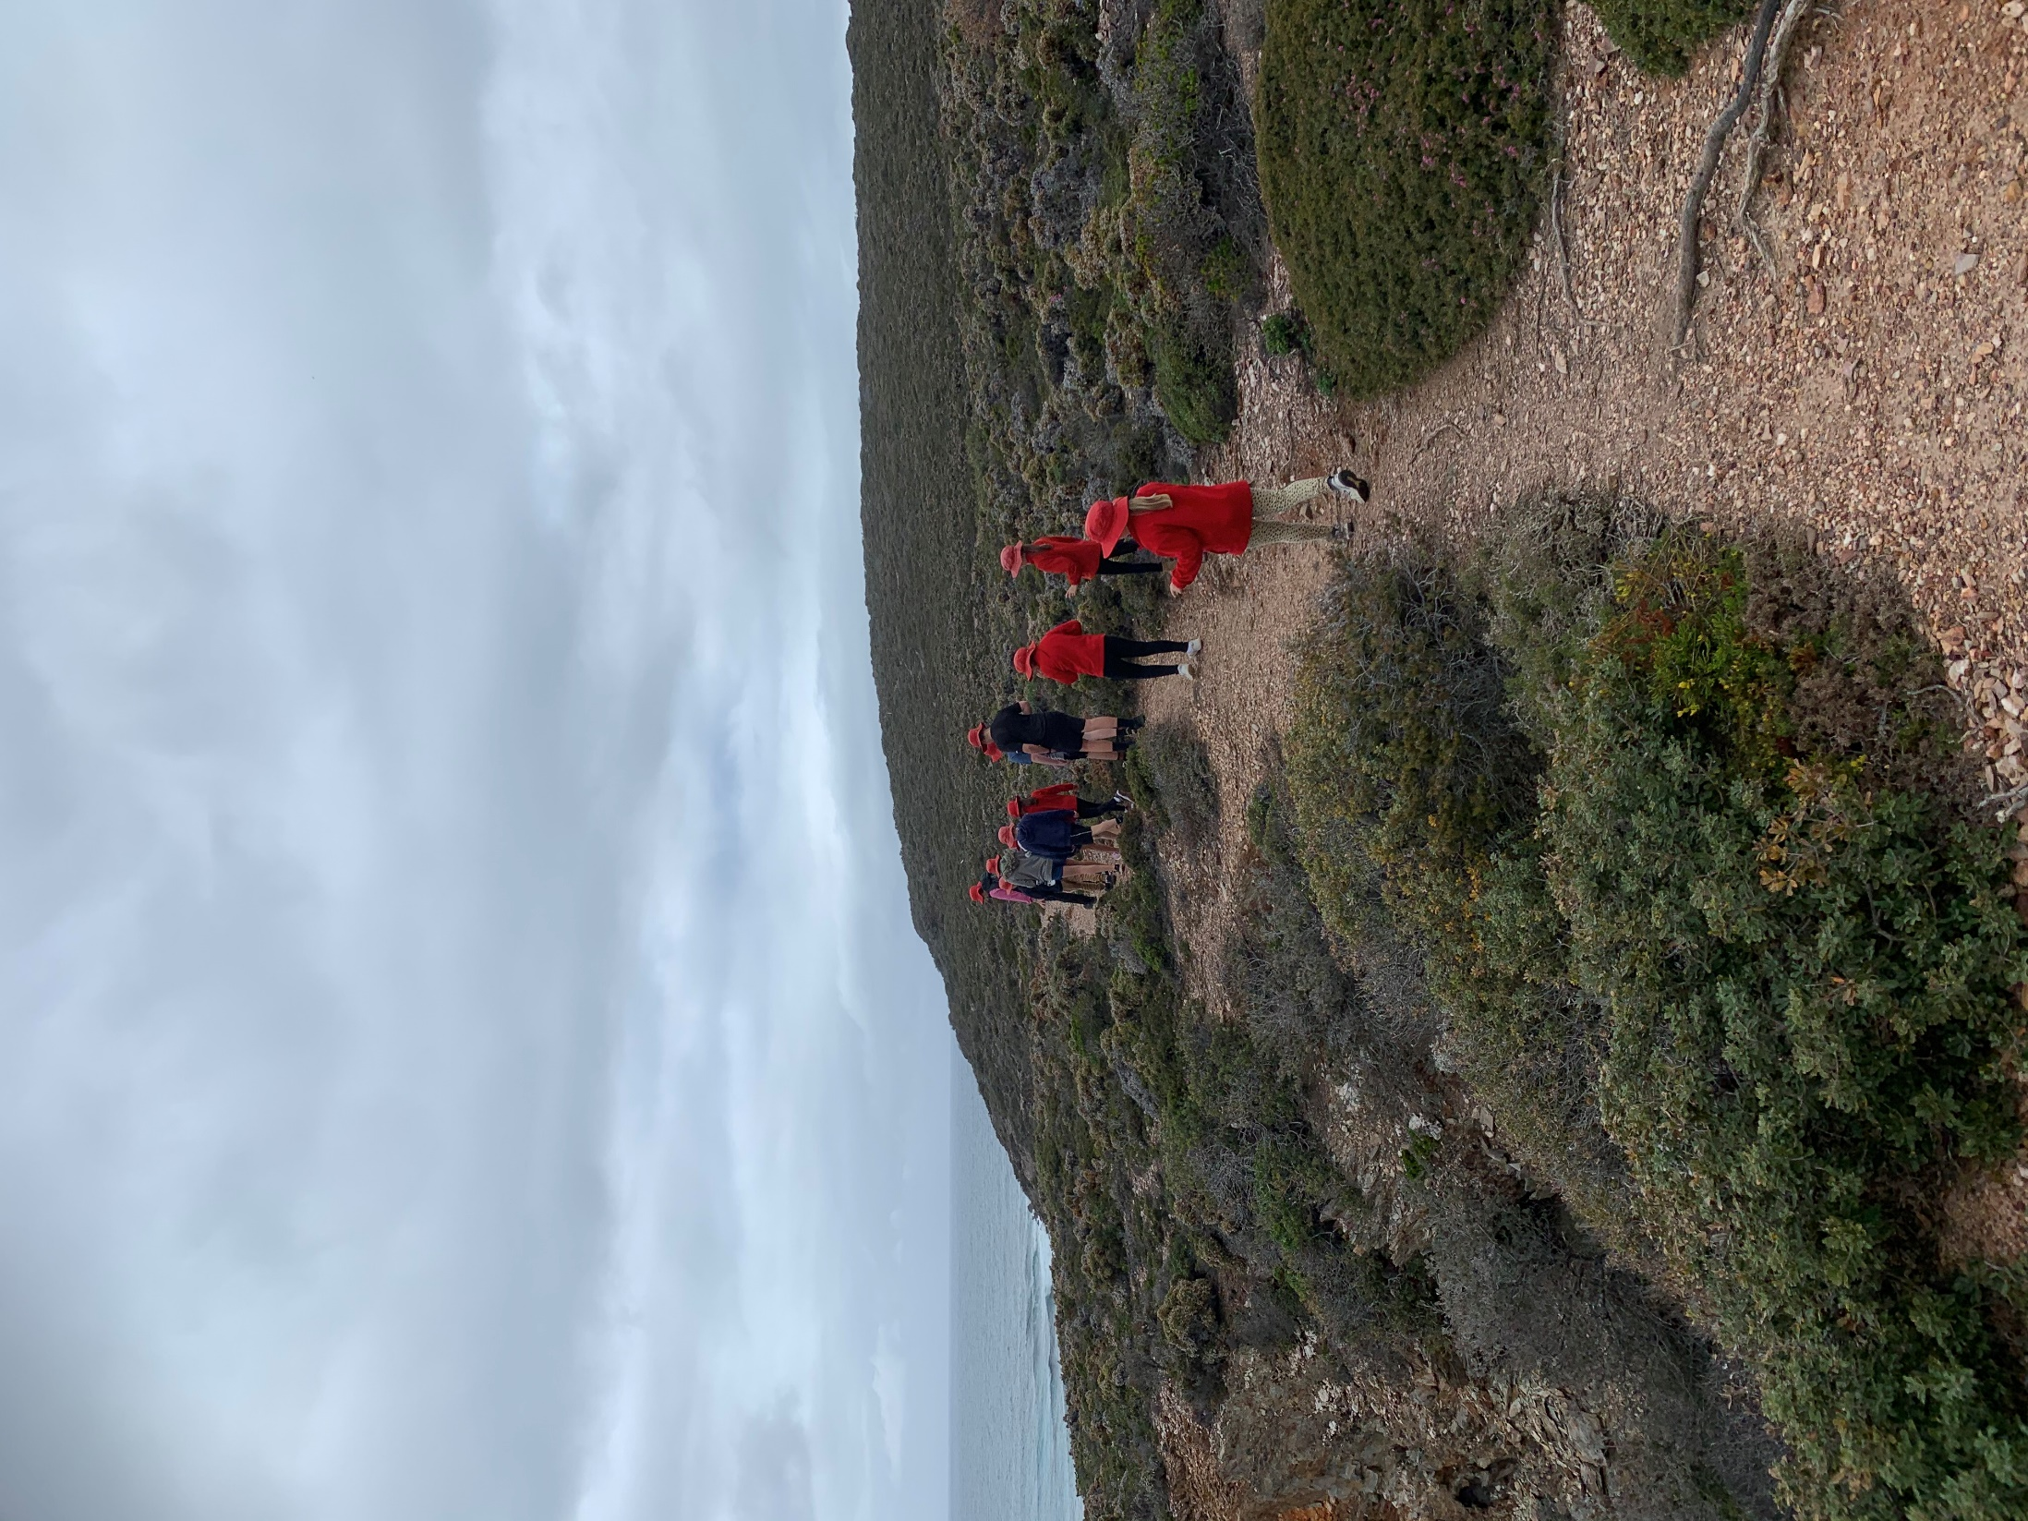
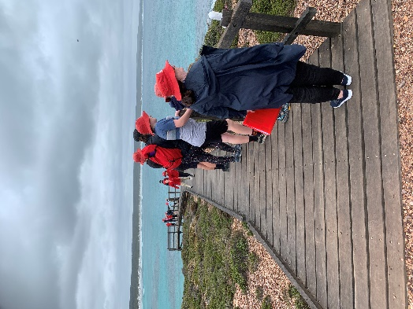
All vehicles were packed and attendees ready by 9a.m. on Wednesday. We first drove to Point Anne and enjoyed morning tea under the shelter overlooking the water and mountains. The weather was drizzly and overcast, no whales in sight. Everyone was suitably attired in rain jackets, good walking shoes and hats.
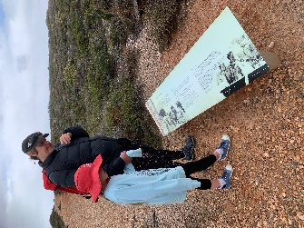
The students were encouraged to read the signs on the Point Anne Heritage Walk Trail and to slow down and be observant. A small kangaroo and her joey happily stayed nearby as we passed.

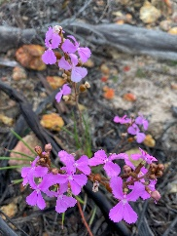

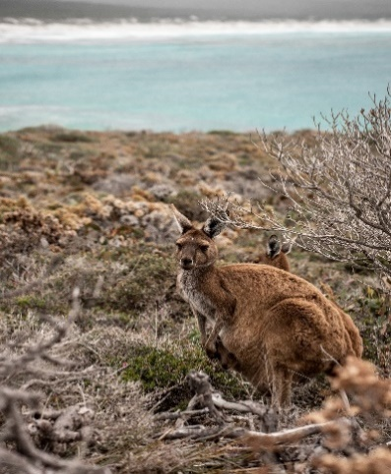

We then travelled to Twertup Field Studies Centre. The students were excited to look all around the accommodation, locate the girls and boys bedrooms, and be slightly alarmed at the “long-drop” toilets.
The proclamation, “It’s better than I thought it would be!”, was heard.
The late lunch was partaken hungrily. Then teachers and students discussed appropriate camp behaviour, respect for others and the environment, required hygiene rules.
The adults secured a bright tape sectioning off the front area from the Quarry edge and established a “No-Go” boundary beyond the tape.
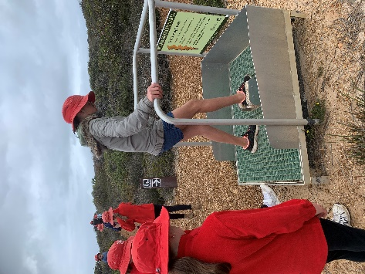
Then everyone proceeded to the Phytopthora boot cleaning station located near the Walk Trail board. We followed the short section of the Twertup Nature Walk self-guided brochure, stopping at each Numbered trail marker to read from the trail information guide. The students took it in turns to read aloud to others and attempted to pronounce the difficult scientific names. This promoted a lot of discussion and questions about the environment.
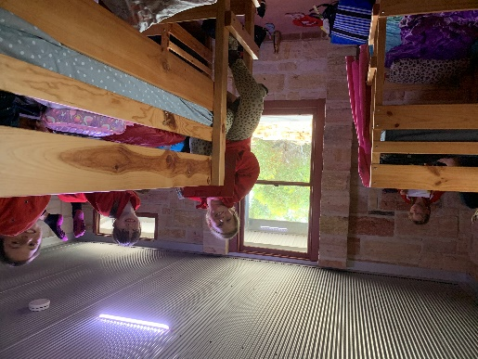
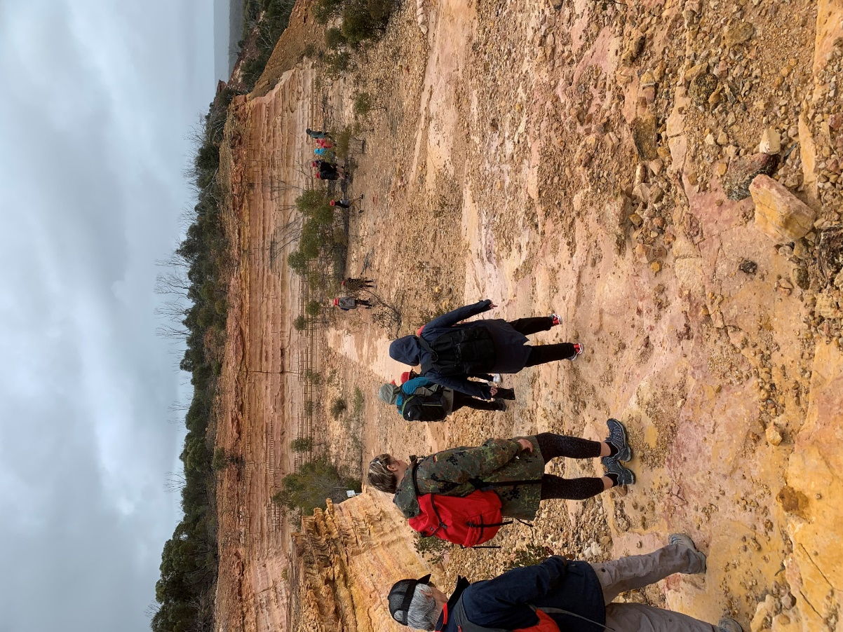
Finishing the walk at the Quarry provided the opportunity to discuss the spongolite, fossils and history of the area. Students were encouraged to look, but not handle the fragmented pieces.
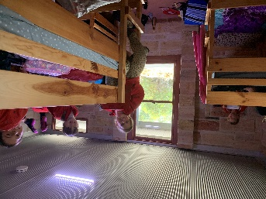
On returning to the building, the students set up beds. The 8 girls had the room with 4 bunk beds and the 4 boys got the room with 2 bunk beds. Perfect arrangement.
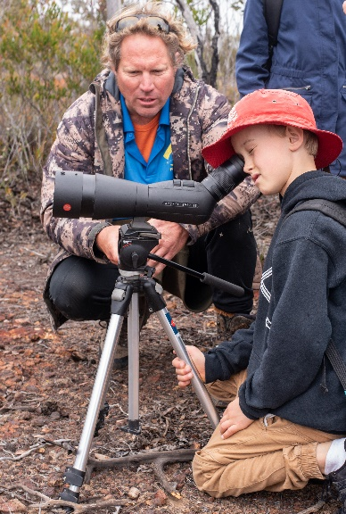
The students completed camp booklet activities while the meal was prepared. Dinnertime, followed by a “chocolate eating game”, then bedtime!!
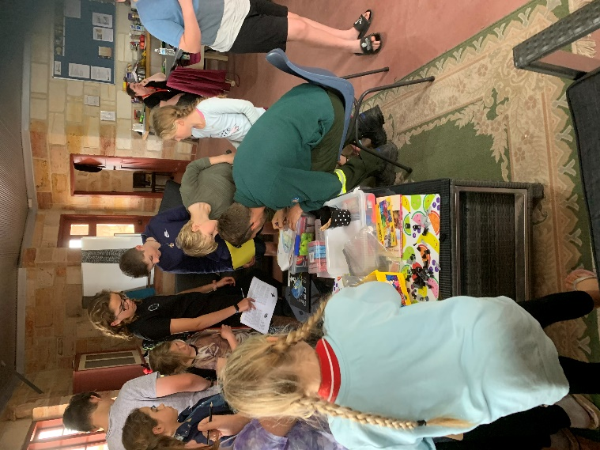
Thursday arrived with the same weather as previous day, overcast and rain/drizzle. Everyone completed all the adventures regardless
- Horrie and Dorrie Walk trail – looking through a telescope from on top.
- Snake bite First Aid lesson.
- Art activities – etchings of plant item, Leaf drawings, clay fossil imprints, spongolite blocks.

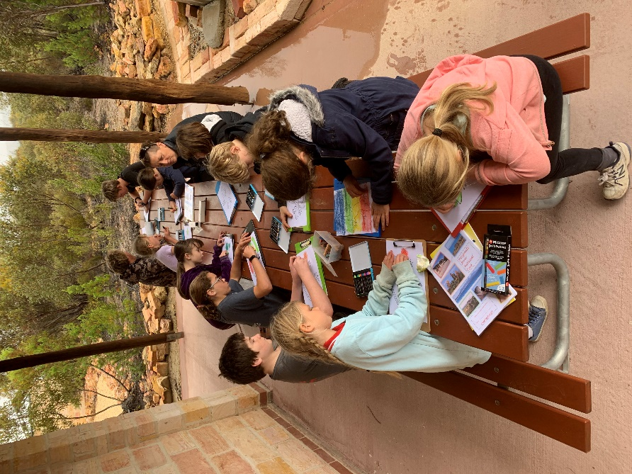

- Visit from Ranger Josh Woods

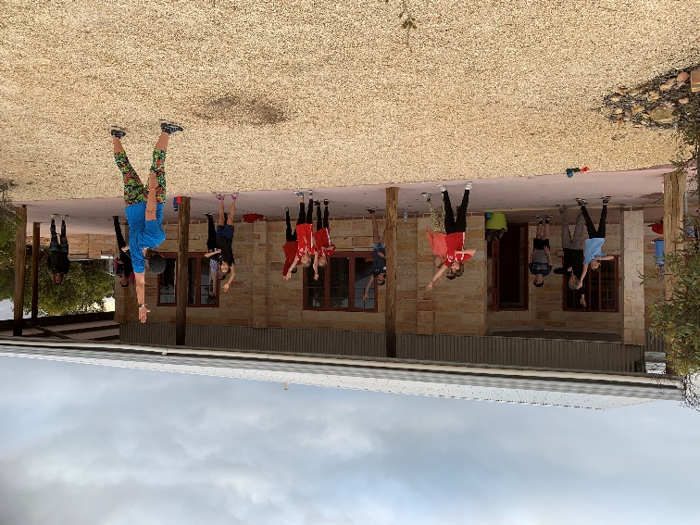
- Zumba action. The Limbo comp.

- Photography Lesson
- Quiz on camp experiences and information learnt.
- Night walk with torches.

